SIMATS ENGINEERING (SAVEETHA SCHOOL OF ENGINEERING)

Department of Computer Science and Engineering
CO2 ASSESSMENT TOOL 2 – Architecture Design Assignment

Course Code: | CSA10 / CSA1063 | Course Title: | Software Engineering
CO Assessed: | CO2 | Assessment: | Assessment Tool 2 – Architecture Design Assignment
Weightage: | 20% | Total Marks: | 25
CO2 Statement: | Perform detailed requirements analysis, design scalable architectures, and prioritize features with a focus on cross-disciplinary skills
Student Name: | M. Kruthika Reddy | Reg. No.: | 192465037
Date: |  | Duration: | 60 minutes
Code of Conduct
I M. Kruthika Reddy/192465037 (Name / Reg No) certify that this submission is my original work and that I have adhered to the guidelines specified for this assessment. I understand that any violation of academic integrity rules will result in disciplinary action.
Signature of the Student:
Annexure A – Architecture Design Assignment

Instructions to Students:

Each student will be assigned an individual software project problem statement. Based on the assigned problem, analyze the system requirements and design an appropriate software architecture by applying software engineering principles. Your submission should demonstrate your ability to select, justify, and evaluate a suitable architectural style.
Question
Based on your assigned problem statement, perform an Architecture Design Analysis and prepare an architecture design report by answering the following questions:

Analyze System Requirements
  - Study the given problem statement and identify the system objectives.
The Cloud Security Monitoring and Vulnerability Assessment Dashboard is a security system designed to continuously monitor cloud infrastructure and identify potential security risks. The system collects security events and information from cloud resources, performs vulnerability assessments, detects suspicious activities, and presents the results through a centralized dashboard. Its main objective is to improve cloud security visibility, identify vulnerabilities at an early stage, prioritize critical risks, and help security teams respond to threats effectively.
Key Points
- Continuous Cloud Monitoring: Monitor cloud resources, logs, and security events continuously.
- Vulnerability Detection: Identify security vulnerabilities and weaknesses in cloud infrastructure.
- Threat Detection: Detect suspicious activities and potential security threats at an early stage.
- Risk Prioritization: Classify vulnerabilities based on severity so that critical issues can be addressed first.
- Centralized Security Dashboard: Display security status, vulnerabilities, alerts, and reports in one platform.
  - Analyze the functional and non-functional requirements that influence the software architecture.
The software architecture of the Cloud Security Monitoring and Vulnerability Assessment Dashboard must support both functional and non-functional requirements. Functional requirements define the major operations of the system, such as user authentication, cloud resource monitoring, vulnerability scanning, threat detection, alert generation, and security reporting. Non-functional requirements define how effectively and securely these functions should operate, including performance, scalability, reliability, availability, security, usability, and maintainability. These requirements influence the architecture by requiring secure communication, modular components, efficient data processing, scalable storage, and reliable monitoring services.
Functional Requirements – Key Points
- Authentication and Access Control: The architecture must support secure login and role-based access for different users.
- Cloud Resource Monitoring: It must collect and process logs, metrics, and security events from cloud resources.
- Vulnerability Assessment: It must integrate vulnerability scanning components and store assessment results.
- Threat Detection and Alerts: It must analyze security events and generate alerts when suspicious activities are detected.
- Dashboard and Reporting: It must provide APIs and data services to display security metrics and generate reports.
Non-Functional Requirements – Key Points
- Performance: The architecture should process security events efficiently and provide fast dashboard responses.
- Security: Communication and stored data must be protected using authentication, authorization, encryption, and secure APIs.
- Scalability: The architecture should support increasing cloud resources, users, logs, and security events.
- Reliability and Availability: Monitoring and alert services should continue operating with minimal failures and downtime.
- Maintainability: The architecture should be modular so that individual components can be updated, tested, or replaced easily.

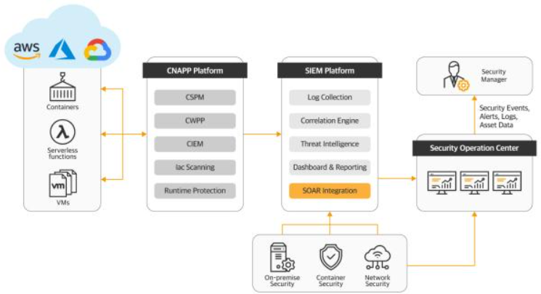
  - Identify key quality attributes such as scalability, maintainability, reliability, availability, performance, and security.

The Cloud Security Monitoring and Vulnerability Assessment Dashboard requires several quality attributes to ensure that the system is secure, efficient, dependable, and capable of handling future growth. Since the system continuously processes cloud security events and vulnerability data, the architecture must support scalability, maintainability, reliability, availability, performance, and security. These attributes directly influence the selection and design of the software architecture and ensure that the system can operate effectively in a real-world cloud environment.
Key Points
- Scalability: The system should support an increasing number of cloud resources, users, security events, and vulnerability records without significant performance degradation.
- Maintainability: The system should use modular and well-structured components so that bugs can be fixed and new security features can be added easily.
- Reliability: The system should provide accurate monitoring, vulnerability results, and alerts while minimizing system failures and data loss.
- Availability: The dashboard and critical monitoring services should remain accessible with minimal downtime, allowing continuous security monitoring.
- Performance: The system should process security events efficiently and provide dashboard information and alerts with minimal delay.
- Security: The system must protect sensitive security data using strong authentication, role-based access control, encryption, secure APIs, and audit logging.

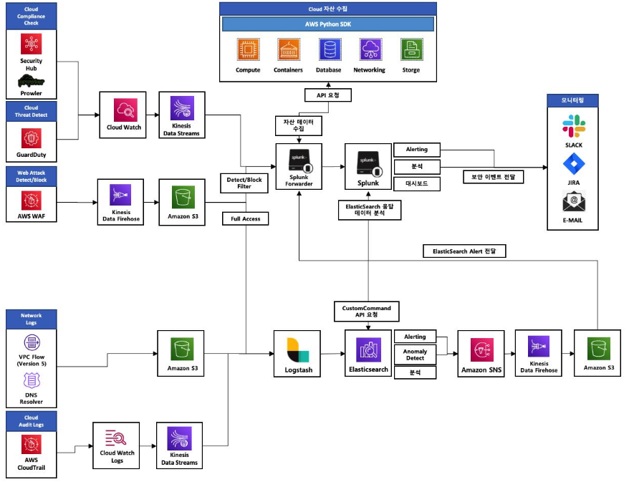

Select a Suitable Software Architecture

  - Select an appropriate architectural style for the proposed system (e.g., Layered Architecture, Client-Server, MVC, Microservices, Event-Driven, Service-Oriented Architecture, Serverless, or Hybrid Architecture).

For the Cloud Security Monitoring and Vulnerability Assessment Dashboard, a Hybrid Architecture combining Microservices and Event-Driven Architecture is the most suitable choice. The system can divide major functions such as authentication, cloud monitoring, vulnerability assessment, threat detection, alert management, and reporting into independent services. An event-driven mechanism can handle continuous security events and alerts asynchronously. This architecture is well suited to a cloud security system because monitoring data can arrive continuously and at high volume, while individual services may need to scale independently.
Key Points
- Microservices: Separate services can be created for authentication, monitoring, vulnerability assessment, threat detection, alerts, and reporting.
- Event-Driven Processing: Security events generated by cloud resources can be sent as events and processed by monitoring and threat-detection services.
- Independent Scalability: High-load components such as monitoring and vulnerability scanning can be scaled independently.
- Fault Isolation: Failure in one service, such as reporting, should not completely stop critical monitoring and alerting functions.
- API-Based Communication: Secure APIs can allow the dashboard and different services to communicate while maintaining controlled access.
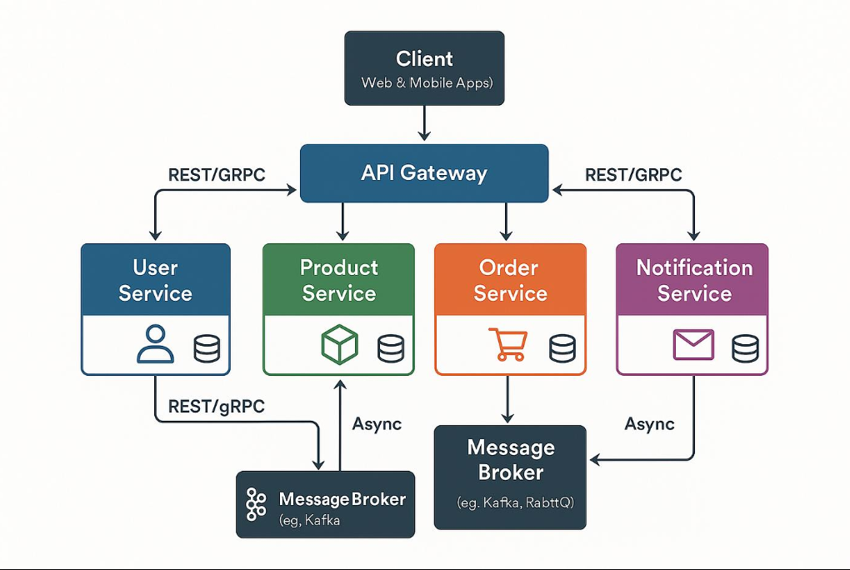
  - Justify why the selected architecture is the most suitable for the given problem.

The Hybrid Microservices and Event-Driven Architecture is appropriate because the proposed system must continuously collect, process, and analyze large amounts of cloud security data. A single monolithic application could become difficult to scale and maintain as the number of cloud resources and security events increases. Microservices provide modularity and independent deployment, while event-driven processing allows security events to be handled asynchronously without blocking other system operations. The combination therefore provides better scalability, performance, reliability, maintainability, availability, and security for the proposed dashboard.
Key Points
- Scalability: Monitoring and vulnerability scanning services can be scaled separately when the workload increases.
- Performance: Event-driven processing allows security events to be processed asynchronously, reducing delays in the dashboard and alert system.
- Maintainability: Individual services can be developed, tested, updated, and maintained independently.
- Reliability and Availability: Failure of one non-critical service does not necessarily bring down the entire security monitoring system.
- Security: Each service can implement appropriate authentication, authorization, encryption, and access controls, making it suitable for handling sensitive security information.
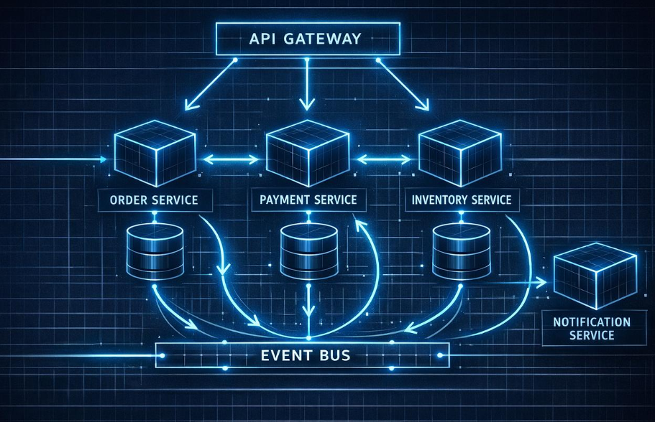

Draw the Software Architecture Diagram

  - Design a clear architecture diagram illustrating the overall structure of the proposed system.
  - Include all major layers/components, databases, external systems, APIs, and communication mechanisms.
  - Use appropriate software architecture notations and labels.

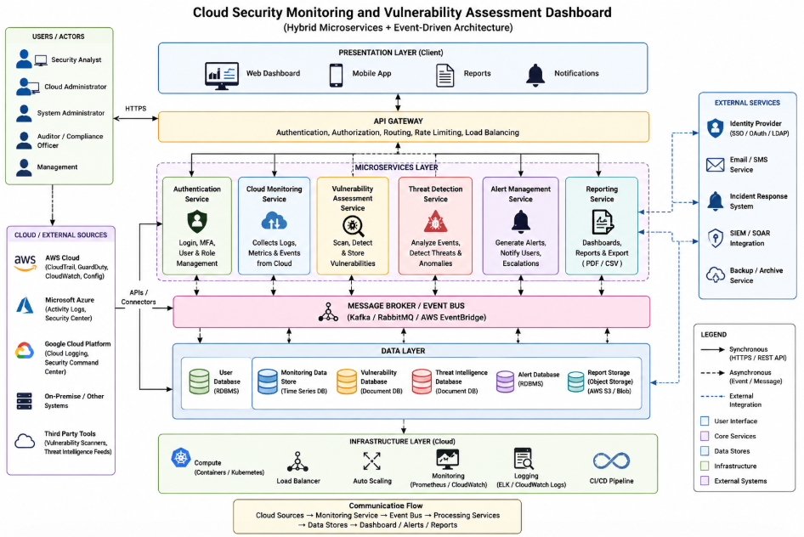

The proposed Cloud Security Monitoring and Vulnerability Assessment Dashboard uses a Hybrid Microservices + Event-Driven Architecture. The architecture consists of a presentation layer, API Gateway, microservices layer, message broker/event bus, data layer, and cloud infrastructure layer. External cloud platforms and security tools provide monitoring and vulnerability data through secure APIs and connectors, while the event bus enables asynchronous communication between services. The dashboard communicates with backend services through HTTPS/REST APIs, and the system uses databases and cloud storage to securely store users, monitoring data, vulnerabilities, alerts, and reports.
Major Components
- Presentation Layer: Web dashboard, mobile interface, reports, and security notifications.
- API Gateway: Handles authentication, authorization, routing, rate limiting, and load balancing.
- Microservices Layer: Authentication, cloud monitoring, vulnerability assessment, threat detection, alert management, and reporting services.
- Message Broker/Event Bus: Enables asynchronous communication and event processing between services.
- Data Layer: Stores user information, monitoring data, vulnerabilities, threat intelligence, alerts, and reports.
- Infrastructure Layer: Provides containers/Kubernetes, load balancing, auto-scaling, monitoring, logging, and CI/CD.
- External Systems: AWS, Microsoft Azure, Google Cloud, identity providers, SIEM/SOAR, email/SMS, backup services, and third-party security tools.

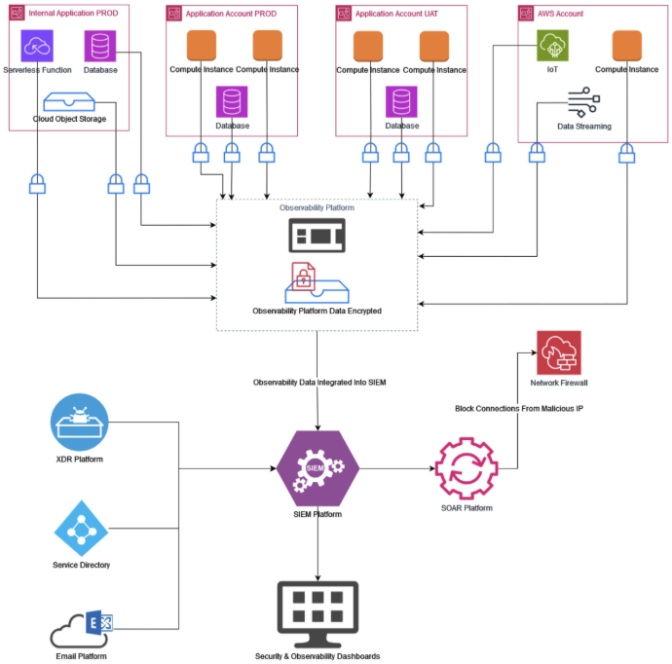
Figure 1: Hybrid Microservices and Event-Driven Architecture for Cloud Security Monitoring and Vulnerability Assessment Dashboard

Explain Components and Their Interactions

  - Describe the purpose and responsibilities of each architectural component.
The Cloud Security Monitoring and Vulnerability Assessment Dashboard consists of multiple components that work together to monitor cloud environments, identify vulnerabilities, detect threats, and present security information. Each component has a specific responsibility, which makes the system modular and easier to maintain. The main components include the presentation layer, API Gateway, authentication service, cloud monitoring service, vulnerability assessment service, threat detection service, alert management service, reporting service, message broker, databases, and cloud infrastructure.
Key Points
- Presentation Layer: Provides the web dashboard through which security analysts and administrators view security events, vulnerabilities, alerts, and reports.
- API Gateway: Acts as the entry point for client requests and manages authentication, authorization, routing, rate limiting, and load balancing.
- Authentication Service: Handles user login, MFA, user roles, and access permissions to ensure that only authorized users access security information.
- Cloud Monitoring Service: Collects logs, metrics, and security events from cloud platforms such as AWS, Azure, and Google Cloud.
- Vulnerability Assessment Service: Scans cloud resources, identifies vulnerabilities, stores assessment results, and assigns severity levels.
- Threat Detection Service: Analyzes security events and identifies suspicious activities, anomalies, and potential threats.
- Alert Management Service: Generates security alerts, sends notifications, and manages alert escalation.
- Reporting Service: Generates dashboards, security reports, analytics, and exportable reports such as PDF or CSV.
- Message Broker/Event Bus: Transfers security events between services asynchronously and allows large volumes of events to be processed efficiently.
- Data Layer: Stores user information, monitoring data, vulnerabilities, alerts, threat intelligence, and reports.

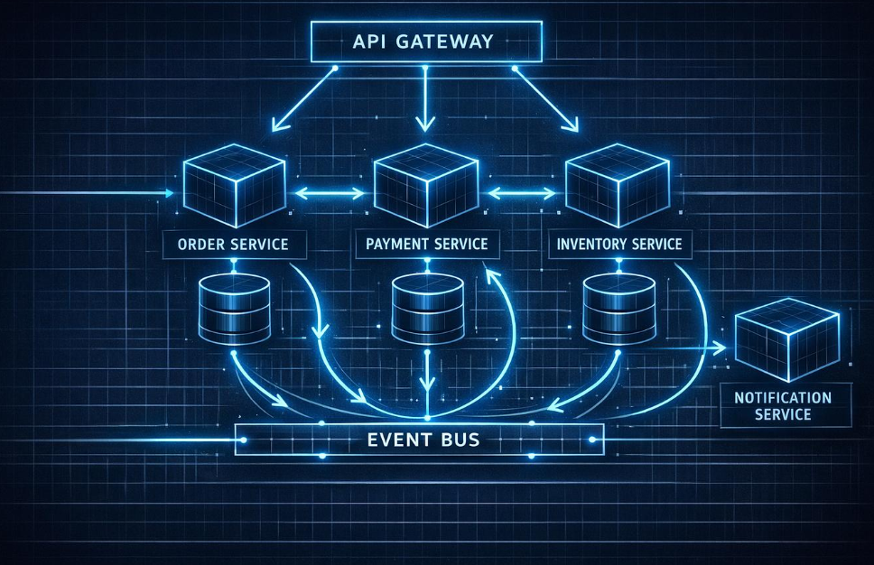
  - Explain how the components communicate and exchange data.
The components communicate using a combination of synchronous and asynchronous communication mechanisms. Users access the system through HTTPS, and their requests are sent to the API Gateway, which forwards them to the appropriate microservice through secure REST APIs. Cloud monitoring and security tools send logs and events through APIs or connectors to the monitoring service. Security events are published to the message broker, where threat detection and alert services consume and process them. Processed results are stored in the appropriate databases and then retrieved by the dashboard and reporting services.
Key Points
- User → API Gateway: Users communicate with the system through secure HTTPS connections.
- API Gateway → Microservices: Requests are routed to services using REST APIs.
- Cloud → Monitoring Service: Cloud platforms send logs, metrics, and events through secure APIs/connectors.
- Services → Event Bus: Security events are published to the message broker/event bus for asynchronous processing.
- Services → Databases: Processed security information is stored in appropriate databases and cloud storage.
- Services → Dashboard: The dashboard retrieves processed data through APIs and displays security status, vulnerabilities, and alerts.

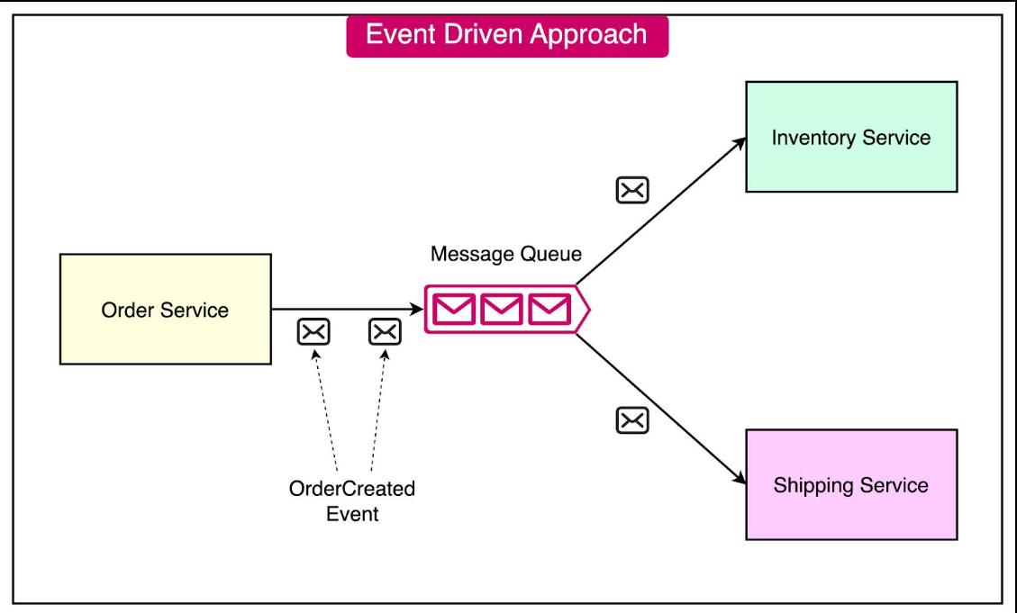
  - Illustrate the overall workflow of the system.
The overall workflow begins when cloud platforms and external security tools provide logs, metrics, and security events to the Cloud Monitoring Service. The collected events are sent to the Message Broker/Event Bus, where the Threat Detection Service analyzes them for suspicious activities and the Vulnerability Assessment Service processes vulnerability scan results. Detected threats generate alerts through the Alert Management Service, while all relevant information is stored in the data layer. Finally, the Dashboard and Reporting Service retrieves the processed information and presents security status, vulnerabilities, alerts, and reports to authorized users.
Workflow
Cloud Resources / Security Tools
↓
Cloud Monitoring Service
↓
Message Broker / Event Bus
↓
Threat Detection + Vulnerability Assessment
↓
Data Storage
↓
Alert Management + Reporting
↓
API Gateway
↓
Web Dashboard / Notifications / Reports
↓
Security Analyst / Cloud Administrator / Management
Two Example Interactions
Example 1 – Threat Detection:
Cloud resource → Security event → Monitoring Service → Event Bus → Threat Detection → Alert Service → Security Analyst.
Example 2 – Vulnerability Assessment:
Cloud resource → Vulnerability Scanner → Vulnerability Assessment Service → Vulnerability Database → Dashboard → Administrator fixes the vulnerability.

Discuss Quality Attributes
Evaluate how the proposed architecture addresses the following aspects:
The proposed Hybrid Microservices + Event-Driven Architecture is designed to meet the major quality requirements of the Cloud Security Monitoring and Vulnerability Assessment Dashboard. The architecture separates system functions into independent services and uses an event-driven communication mechanism, allowing the system to handle increasing security data while maintaining security, performance, reliability, and availability.
1. Scalability
The architecture can scale individual microservices independently according to workload. This is important because cloud monitoring and vulnerability scanning may generate large amounts of data.
- Example 1: Additional monitoring service instances can be deployed when the number of cloud resources increases.
- Example 2: Vulnerability scanning services can be scaled during large or scheduled scanning operations.
2. Security
Security is implemented through multiple layers, including authentication, role-based access control, encrypted communication, secure APIs, and protected databases. The API Gateway provides a central point for controlling access to backend services.
- Example 1: Only authorized security analysts can access vulnerability and threat information.
- Example 2: HTTPS and encryption protect security data while it is transmitted between users, services, and cloud platforms.
3. Performance
The event-driven architecture improves performance by processing security events asynchronously through the message broker. The API Gateway and independently scalable services also prevent heavy workloads in one component from affecting the entire system.
- Example 1: Thousands of security events can be placed in the event queue and processed by monitoring and threat-detection services.
- Example 2: Dashboard requests can be handled separately without waiting for a complete vulnerability scan to finish.
4. Reliability
The architecture improves reliability by separating functions into independent services and storing security information in dedicated data stores. If a non-critical service fails, other services can continue operating.
- Example 1: If the reporting service fails, cloud monitoring can continue collecting security events.
- Example 2: Events can remain in the message queue temporarily if a processing service becomes unavailable.
5. Maintainability
Microservices make the system easier to maintain because each major function is separated into an independent module. Developers can modify, test, or update one service without changing the entire application.
- Example 1: The vulnerability assessment service can be upgraded without modifying the authentication service.
- Example 2: A new reporting feature can be added without redesigning the cloud monitoring component.
6. Availability
The architecture supports high availability through load balancing, auto-scaling, redundant service instances, and distributed cloud infrastructure. Critical services can continue operating even when individual components experience failures.
- Example 1: If one monitoring service instance fails, another instance can continue processing security events.
- Example 2: Load balancing can distribute dashboard requests across multiple service instances to reduce downtime.
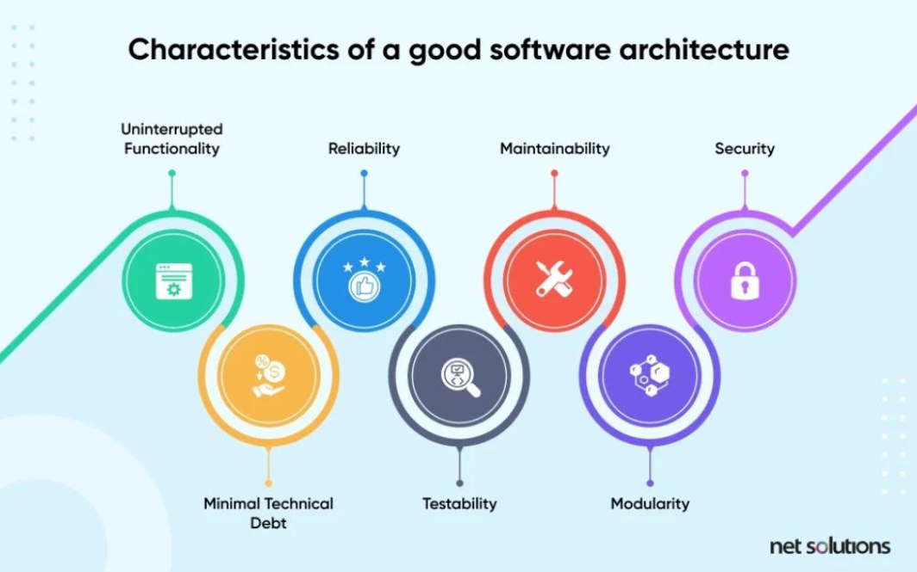

Justify Architectural Decisions

  - Explain the rationale behind your architectural choices.

The Hybrid Microservices + Event-Driven Architecture was selected for the Cloud Security Monitoring and Vulnerability Assessment Dashboard because the system needs to handle multiple security functions and a continuous flow of cloud security events. Microservices allow functions such as authentication, cloud monitoring, vulnerability assessment, threat detection, alert management, and reporting to operate independently. The event-driven approach allows security events to be processed asynchronously through a message broker, improving scalability and performance. This architecture also supports secure API-based integration with cloud platforms and external security tools.
Key Points
- Modularity: Microservices separate major system functions, making the system easier to develop and manage.
- Scalability: Individual services such as monitoring and vulnerability scanning can be scaled independently according to workload.
- Performance: Event-driven processing allows large numbers of security events to be processed asynchronously without blocking other services.
- Security: An API Gateway, authentication service, role-based access control, and secure communication provide multiple layers of protection.
- Integration and Flexibility: APIs and event-based communication make it easier to integrate AWS, Azure, Google Cloud, vulnerability scanners, SIEM systems, and future security tools.

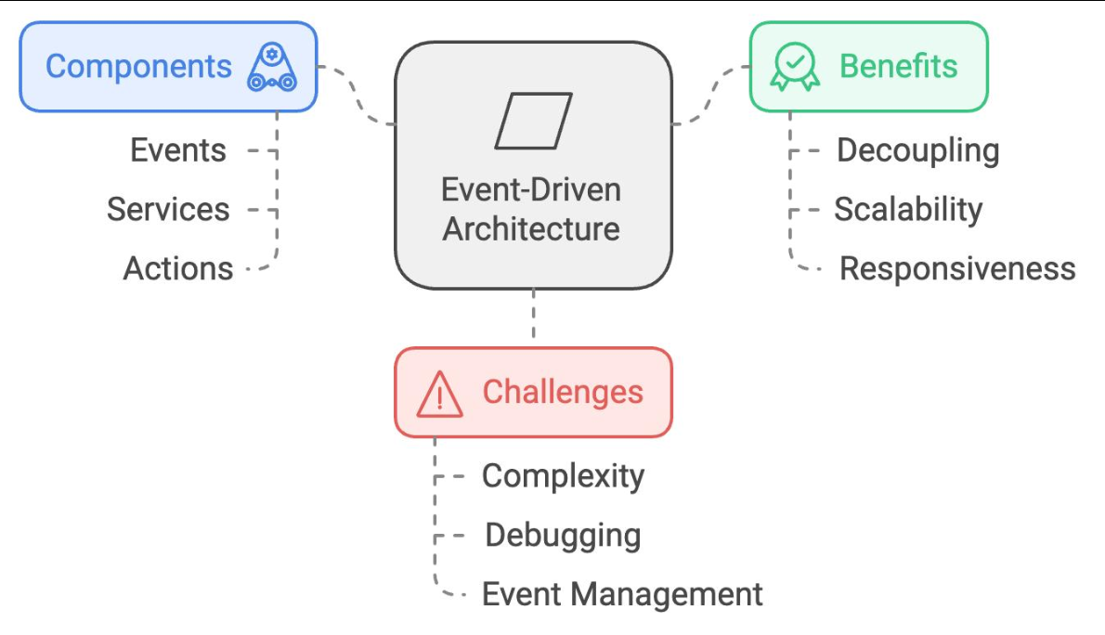
  - Discuss the trade-offs considered while selecting the architecture.

While selecting the Hybrid Microservices + Event-Driven Architecture, several trade-offs were considered. The architecture provides strong scalability, flexibility, fault isolation, and performance, but it is more complex to develop, deploy, monitor, and maintain than a simple monolithic or layered architecture. For the Cloud Security Monitoring and Vulnerability Assessment Dashboard, the additional complexity is justified because the system needs to process continuous security events, support multiple cloud services, and allow individual security components to scale independently.
Key Points
- Scalability vs Complexity:
Microservices can scale individual components independently, but managing multiple services increases deployment and configuration complexity.
- Performance vs Communication Overhead:
Event-driven processing improves handling of large security-event volumes, but communication between multiple services and message queues can introduce some latency.
- Reliability vs Infrastructure Cost:
Multiple service instances and redundant components improve reliability, but they require additional cloud resources and therefore increase operational costs.
- Maintainability vs Management Effort:
Independent services are easier to update and maintain individually, but developers must manage service communication, monitoring, logging, and version compatibility.
- Flexibility vs Security Management:
APIs make integration with cloud platforms and security tools easier, but every API and service introduces additional security points that require authentication, authorization, monitoring, and protection.

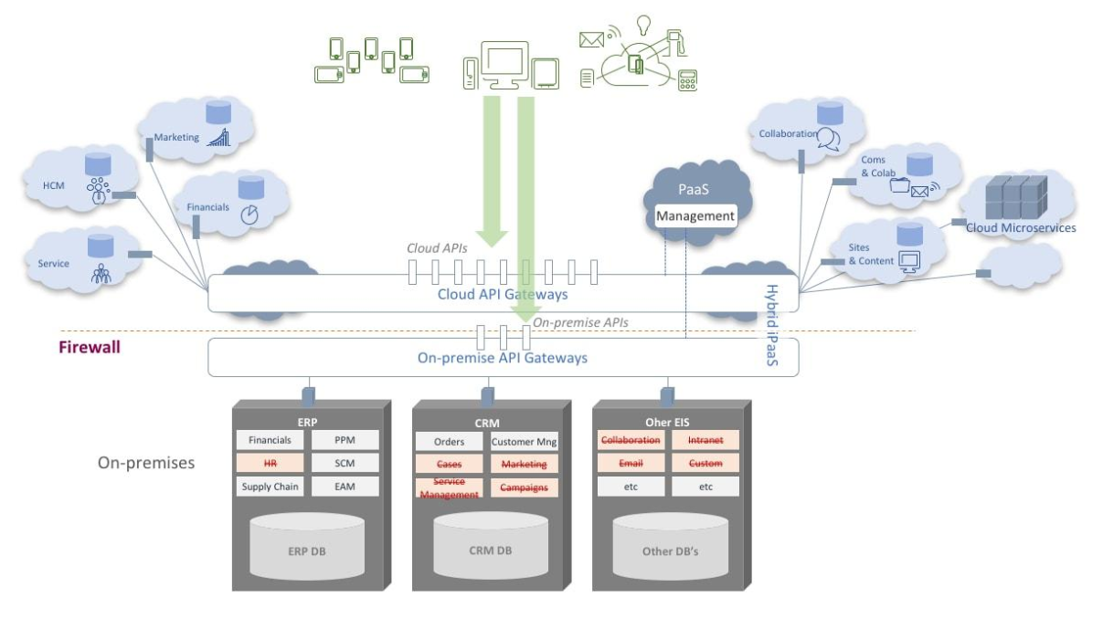
  - Explain how the chosen architecture supports future enhancements, system integration, and long-term maintainability.

The Hybrid Microservices + Event-Driven Architecture supports future growth because each major function is developed as an independent service and communicates through secure APIs and events. This allows new features, cloud platforms, security tools, and analytics capabilities to be added without redesigning the entire system. The architecture also improves long-term maintainability because individual services can be updated, tested, scaled, or replaced independently while the remaining services continue operating.
Key Points
- Future Enhancements:
New features such as AI-based threat detection or automated remediation can be added as separate services without changing the existing core architecture.
- System Integration:
Secure REST APIs and event-based communication allow integration with AWS, Azure, Google Cloud, SIEM systems, vulnerability scanners, and threat intelligence platforms.
- Independent Updates:
Individual services can be modified or upgraded independently, reducing the risk of affecting the entire system.
- Easy Scalability:
New instances or services can be added when the number of cloud resources, users, or security events increases.
- Long-Term Maintainability:
Modular services, standardized APIs, centralized logging, automated testing, and CI/CD practices make the system easier to maintain, troubleshoot, and extend over time.

Rubrics for Calculation
Evaluation Criteria | Excellent (4 Marks) | Good (3 Marks) | Satisfactory (2 Marks) | Needs  Improvement (1 Mark)
System  Requirement Analysis (30%) | Thoroughly analyzes the problem statement, accurately identifies functional and non-functional requirements, and clearly explains quality attributes influencing the architecture. | Analyzes most  requirements with minor omissions or limited explanation. | Identifies only basic  requirements with partial analysis. | Requirement analysis is incomplete, inaccurate, or lacks clarity.
Selection of Software  Architecture (25%) | Selects the most appropriate architectural style  with strong technical justification aligned to system requirements. | Selects a suitable architecture with reasonable justification. | Architecture is partially  suitable with limited justification. | Inappropriate architecture selected or justification is missing.
Architecture Diagram and Component Design (20%) | Produces a clear, complete, and well-structured  architecture diagram with all major components, interfaces, and  interactions accurately represented. | Diagram is mostly complete with minor omissions or notation issues. | Diagram  includes only essential  components and lacks sufficient detail. | Diagram is incomplete, unclear, or technically incorrect.

Component Interaction and Quality  Attribute  Analysis (15%) | Clearly explains component responsibilities, interactions, and thoroughly discusses scalability, security, performance, reliability, maintainability, and availability. | Explains most  components and quality attributes with minor gaps. | Provides limited explanation of  interactions and addresses only some quality attributes. | Component  interactions and quality  attributes are poorly explained or missing.
Architectural Justification and Technical Presentation (10%) | Provides strong justification for architectural decisions, discusses trade-offs and future enhancements, and presents a  well-organized, professional report. | Provides adequate justification with minor gaps; report is well organized. | Limited justification with minimal discussion of trade-offs or future scope; report needs  improvement. | Justification is weak or absent; report lacks organization and technical clarity.

Criteria | Mark
System Requirement Analysis (30%) | /5
Selection of Software Architecture (25%) | /5
Architecture Diagram and Component Design (20%) | /5
Component Interaction and Quality Attribute Analysis (15%) | /5
Architectural Justification and Technical Presentation (10%) | /5
TOTAL | /25

